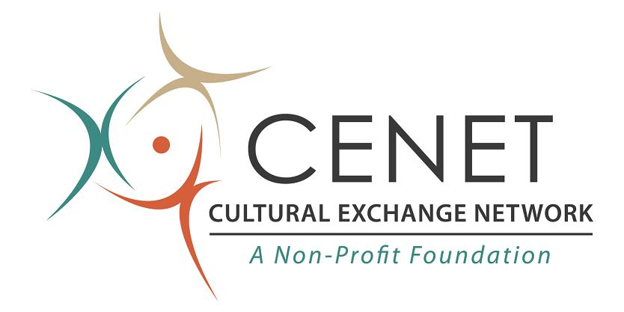

Terms & Conditions

1. I, the undersigned, an applicant for Cultural Exchange Network's (CENET's) International Training/Intern
Program, understand that CENET will provide the DS-2019 forms to applicants who are accepted to CENET's Training/Intern Program. I further understand that CENET cannot guarantee that applicants will receive a J-1 visa from the U.S. Consulate in their home country. CENET has no control over decisions made by the U.S. Consulate or its officers. Exchange Visitor visas are issued with the understanding that participants will RETURN TO THEIR HOME COUNTRY at the conclusion of the J-1 visa program. The burden of proof is on the part of the participant to prove to the U.S. Consul clear intention to return home.

2. I am aware that in accordance with Training/Intern Program regulations, I cannot change my training/intern site
without CENET's authorization. I understand that I cannot hold a position outside of my training/intern site. I understand
that I am only authorized to train/participate as an intern during the dates listed on my DS-2019. I agree that I will not
train/participate as an intern before or after these dates. I also understand that if no earlier departure date is indicated on my
I-94 card, I may remain in the U.S. for up to 30 days after the termination date listed on my DS-2019. I understand that this
30-day "grace period" is for the purposes of travel and departure preparations ONLY. I know that I cannot train/participate
as an intern during this grace period, nor can I travel outside the U.S. and re-enter the U.S. using this DS-2019.

3. I testify that I have read and understand the rules and regulations, and to the best of my knowledge, I am
eligible for the program. I will abide by all program rules and regulations mentioned either in this document or in any other program materials made available to me. I understand that my failure to abide by any of the program rules and regulations may result in the rejection of my application, or in termination from the Training/Intern Program with no refund.

4. I authorize CENET, or its representative agents, to release any information provided as part of my application materials for the purpose of training/internship placement and/or housing. I understand that this release may take the form of photocopy, verbal, and/or electronic transfer of the information contained in the application materials.

5. I understand that all persons entering the U.S. in Exchange Visitor (J-1) status are required by law to be covered by adequate health insurance. I understand CENET will provide, for an additional fee, a policy that meets the requirements of the regulations. CENET is not the insurer, but is only making this policy available. I further understand I am only covered during the dates listed on my DS-2019, and that if I enter the U.S. early or if I stay for the optional grace period, I am not covered by insurance during these times. I understand that if I want to be covered by insurance during the grace period, I must contact the insurance company directly and arrange for coverage at my own expense.

6. I do waive and release all claims against CENET and its agents, and any other persons or organizations utilized by CENET, for any injury, loss, damage, accident, inconvenience, illness, or irregularity resulting from negligence, omissions, or any wrongful acts (both intentional and unintentional) of and by third parties associated with the training/internship sites participating in this program. I further waive and release all claims against CENET and its agents, and any other persons or organizations utilized by CENET, for any injury, loss, damage, accident, inconvenience, illness, or irregularity resulting from the use of a vehicle, and/or such events as strikes, natural disasters, closures of airports or hotels, default or omission of any common or private carrier, and/or negligence, omissions, or any other wrongful acts (both intentional and unintentional) of and by any third party providing services or facilities related to or included in the Training/Intern Program.

7. I do hereby release CENET and its agents, and agree to indemnify them, with regard to any financial obligations, claims, or liabilities, both known and unknown, that I may personally incur directly or indirectly, or be incurred on my behalf, or any damage or injury to the person or property of others that I may cause directly or indirectly, or have caused, while participating in the Training/Intern Program.

8. I do swear that I, or my parent or legal guardian, will make available a total of no less than $2,000 U.S. for the period of the program. This money is in addition to any passage money needed for return home. I understand that CENET will not be.

9. I affirm that all information supplied on the application, and all other documents submitted to CENET, are complete and accurate. I further affirm that by signing this application that I have read and understand each and every provision of this application, and that any misunderstanding should be resolved by contacting CENET directly prior to signing this application. I understand that any misrepresentation or change of facts could be cause for rejection of my application or suspension from the Training/Intern Program with no refund.

10. I understand that CENET does not issue documentation for dependents intending to enter the USA on a J-2 Visa.

Applicant's Legal Name:_______________________________________

Applicant's Passport Number or Country ID:___________________________

